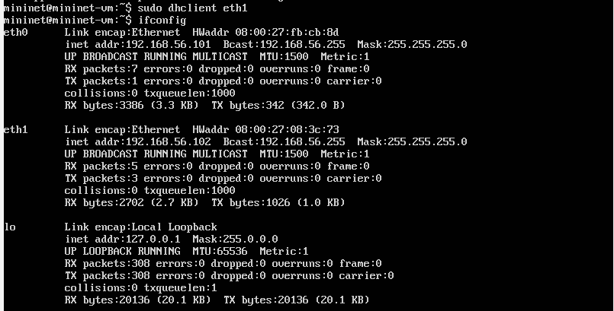  
  
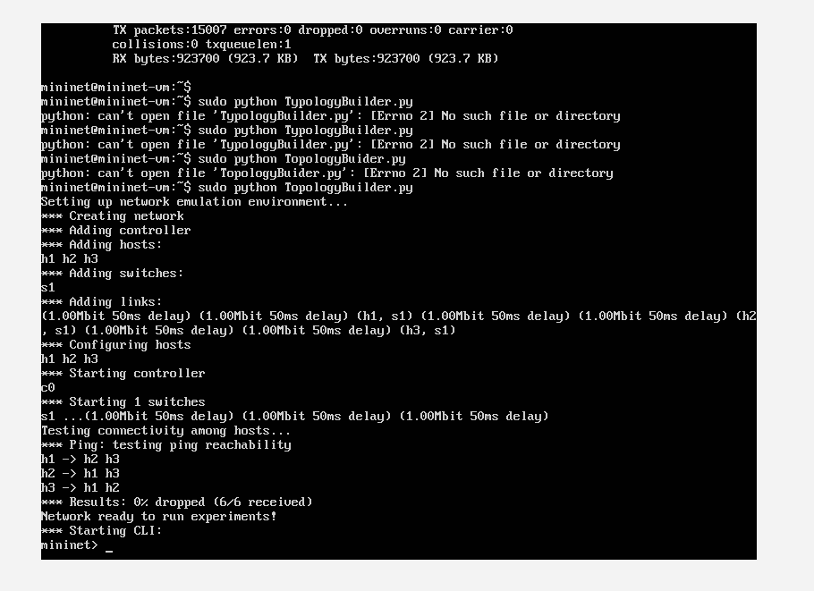

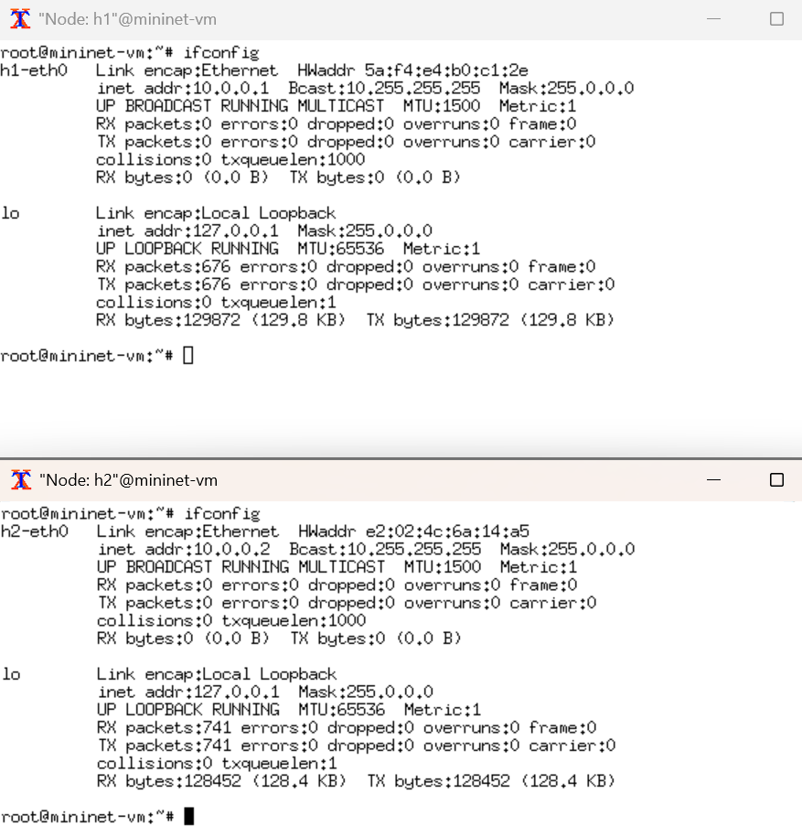  
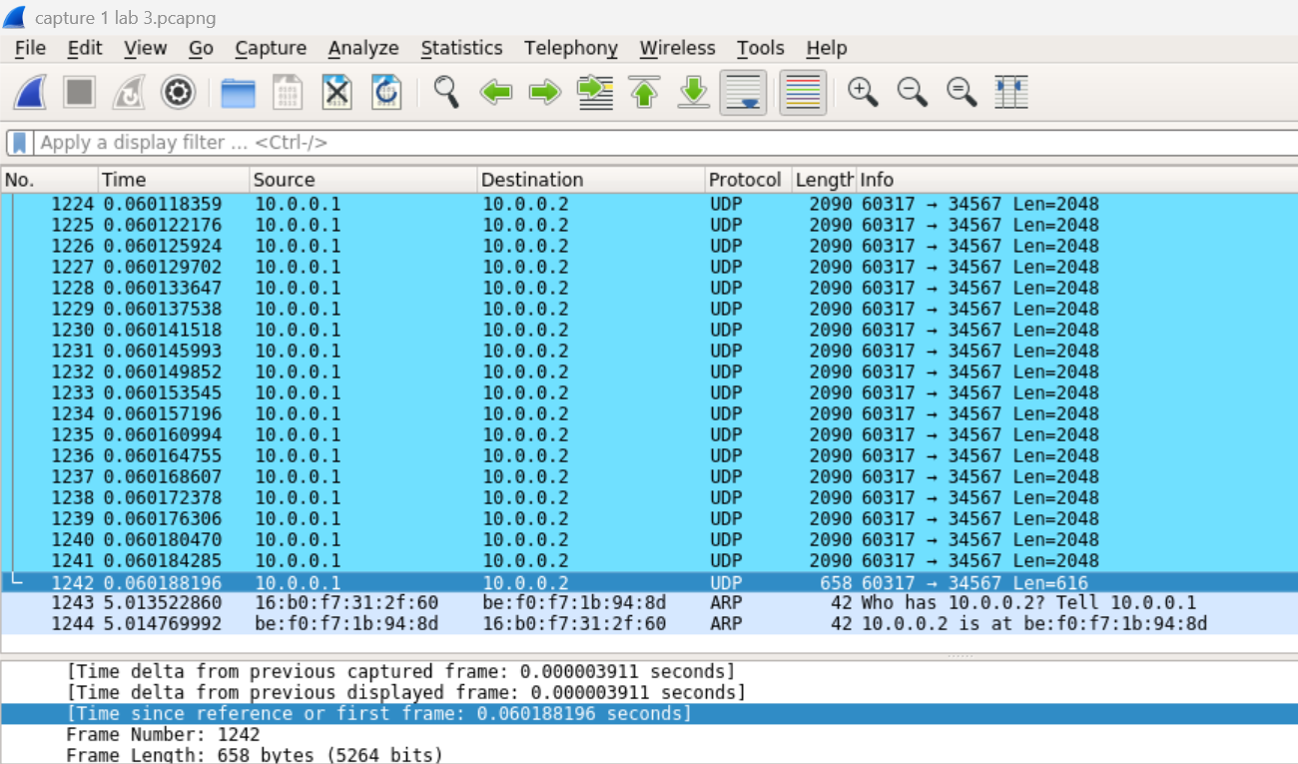

Q1: It took around 0.06019s to transfer the file. UDP packets are all sent from h1 to h2.  
Q2: Yes image is the same.  
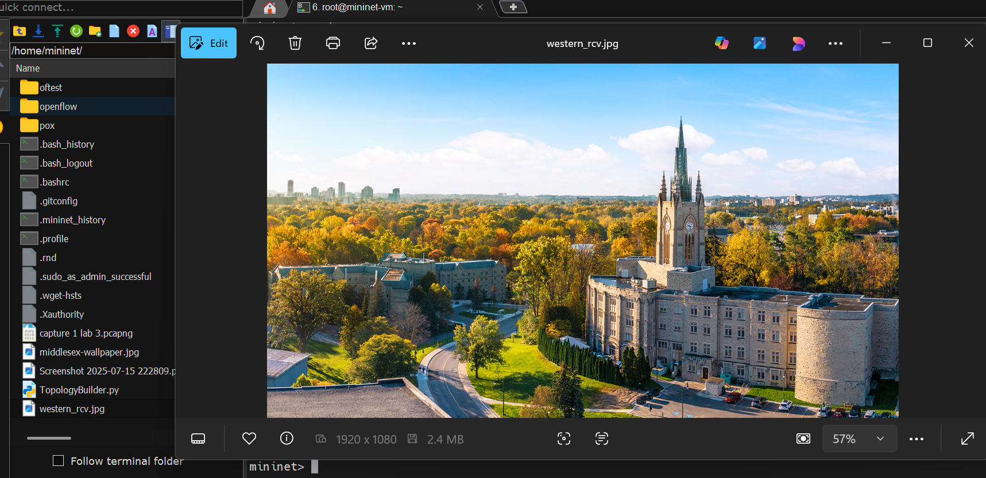  
  
  
  
  
Q3: This time with the delay, the file transfer took 16.369 seconds and the picture is corrupted.  
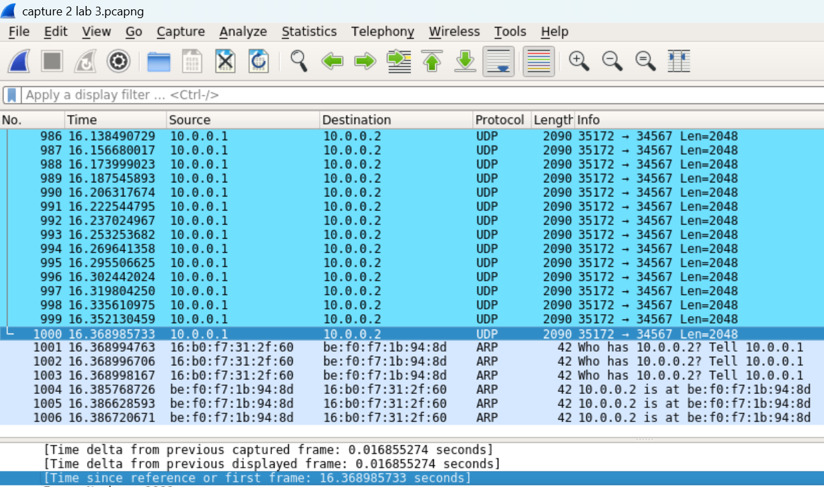

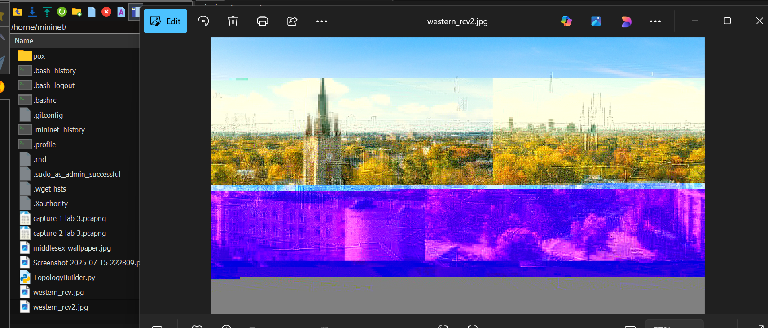

Task 3:   
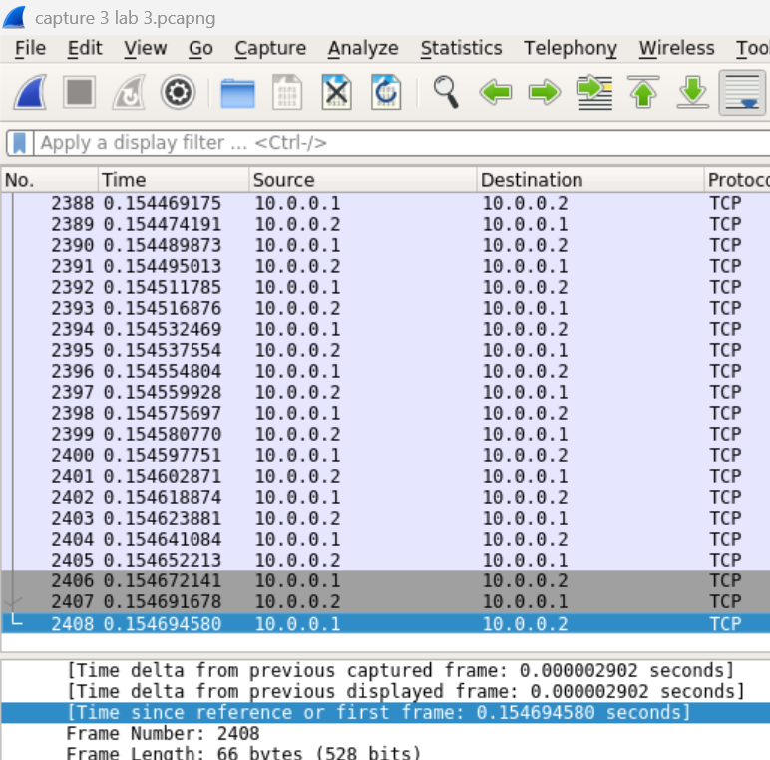  
  
Q4: There are TCP packets in both directions.  
  
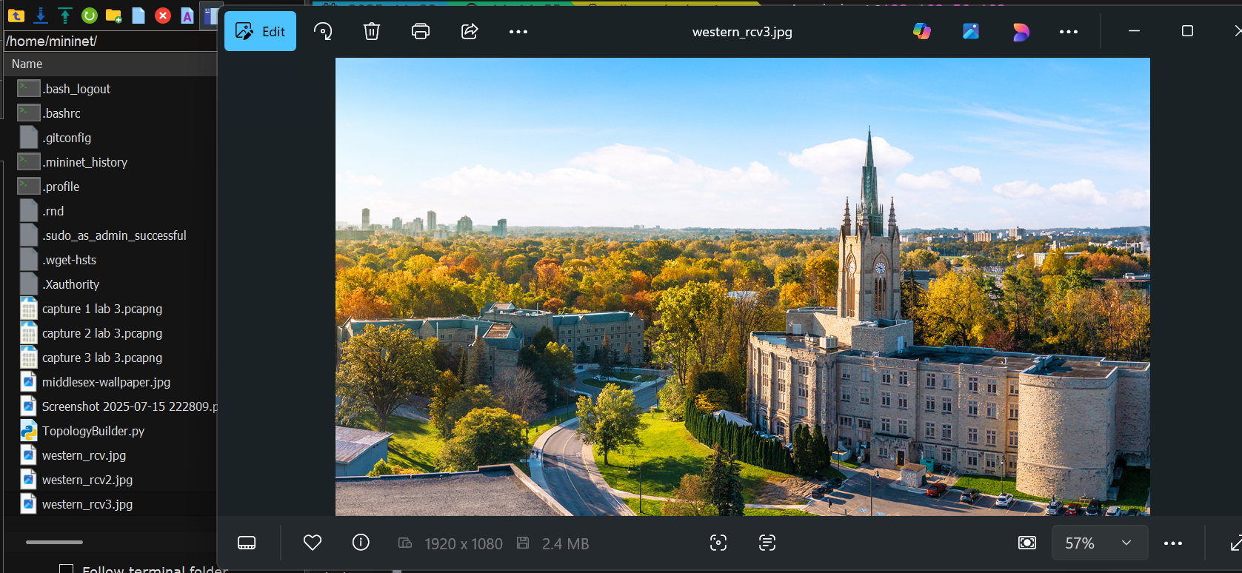  
  
Q5: Same image, same size (2.43 MB)

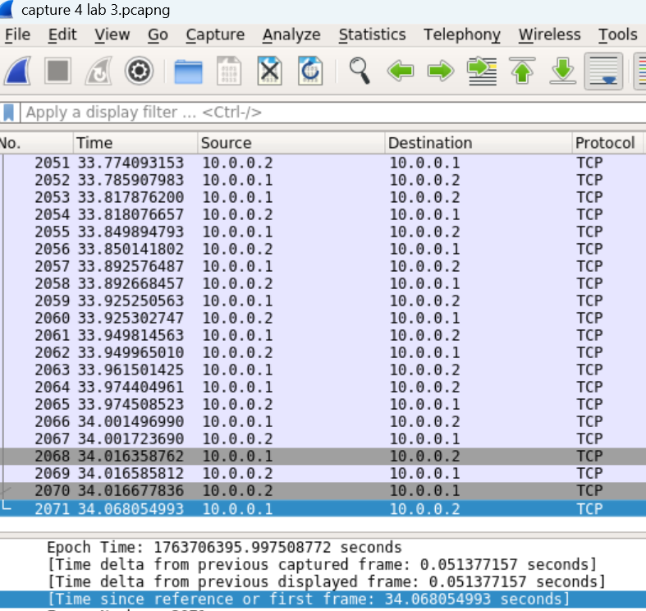

Q6: image is the same despite packet loss, but file transfer took significantly more time

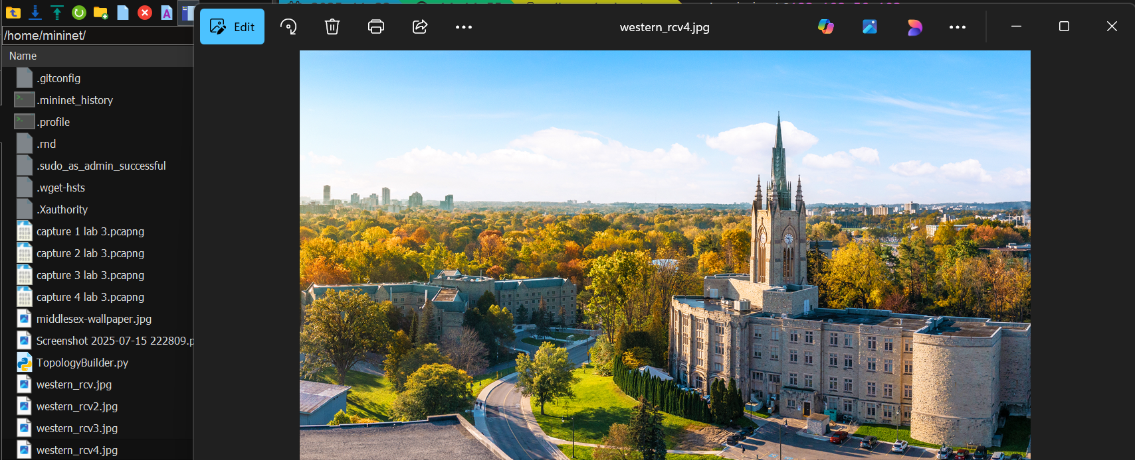

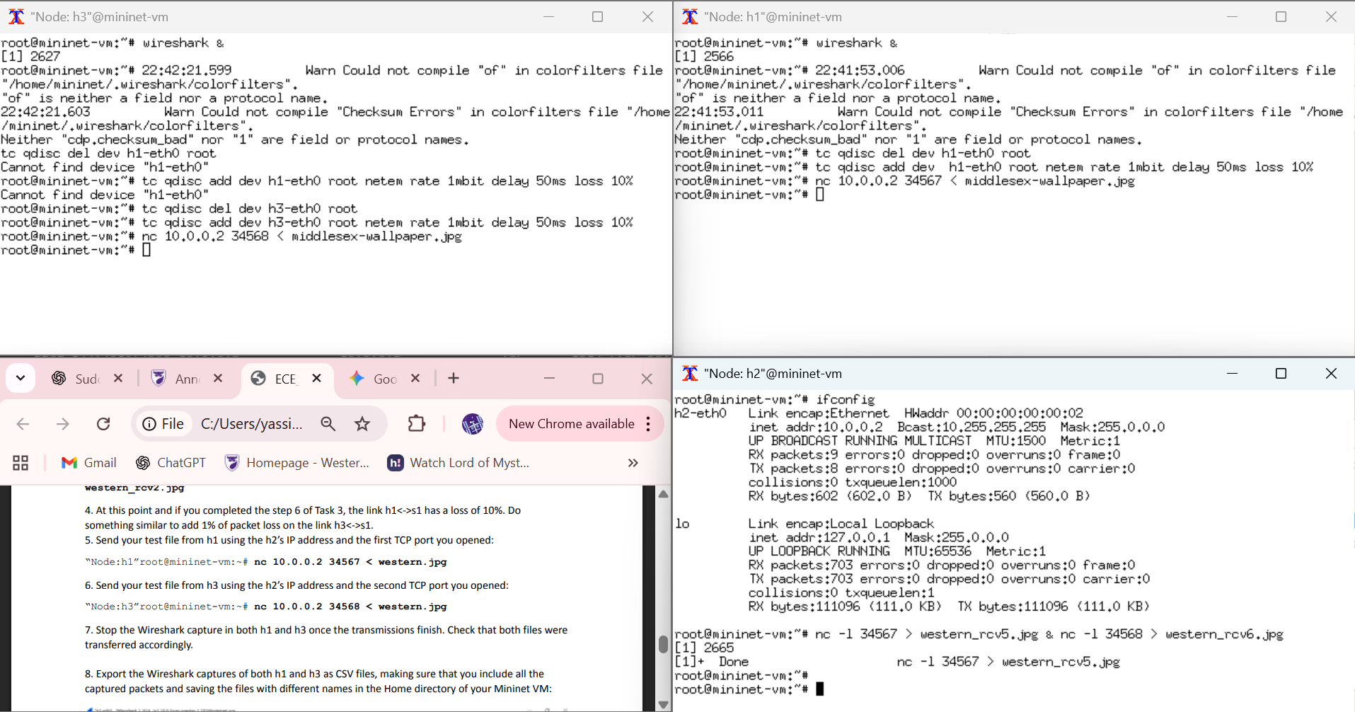

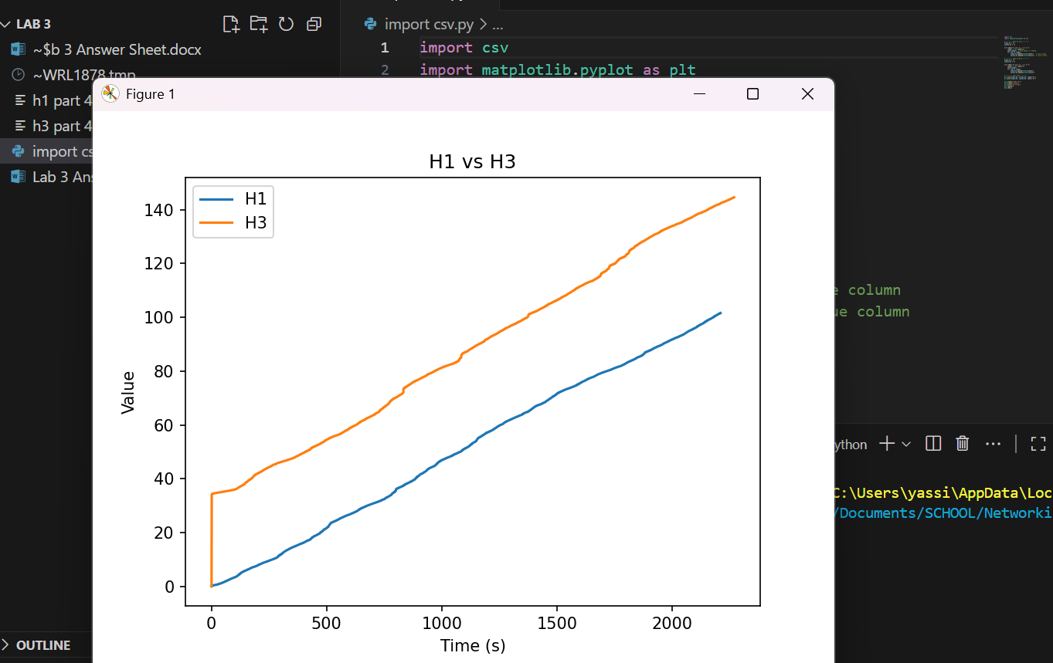  
Q8: The slope is the same because the loss rate is the same (10%). H3 had already grown its congestion window slightly before the capture began, so its calculated window starts higher. Even with the same loss, independent TCP sessions naturally begin with different initial window values, creating the vertical offset.